# **Chapter 4**

# **IMPLEMENTATION AND TESTING OF THE NEW SYSTEM**

## **Introduction**

This chapter describes the development of “E-PARLIAMENT SYSTEM”. It includes a brief overview of the technologies used to make the application, operation, tests that have been applied. Last but not least, software and hardware compatibility requirements.

## **Technologies used**

* To develop this application I have used different technologies and tools namely:
  + **IntelliJ IDEA 14.1.4** for the conception of the graphic interfaces allowing the users to interact with the new system.
  + **MySQL** that I have used to create the database.
  + **JSF Technology** that I have also used while programming.
  + **Java**(programming language)
  + **Bootstra*p*** (front-end framework for making look and feel html elements)
  + **CSS** that I have used to make well looking fonts and pages style.
  + **iText:** I have used this one to be able to generate reports of done transactions.
  + **Javascript&jquery** (for adding managing page behavior)

**Java Server Faces (JSF) Technology**

JavaServer Faces (JSF) is a new standard Java framework for building Web applications. It simplifies development by providing a component-centric approach to developing Java Web user interfaces. JavaServer Faces also appeals to a diverse audience of Java/Web developers. "Corporate developers" and Web designers will find that JSF development can be as simple as dragging and dropping user interface (UI) components onto a page, while "systems developers" will find that the rich and robust JSF API offers them unsurpassed power and programming flexibility. JSF also ensures that applications are well designed with greater maintainability by integrating the well-established Model-View-Controller (MVC) design pattern into its architecture. Finally, since JSF is a Java standard developed through Java Community Process (JCP), development tools vendors are fully empowered to provide easy to use, visual, and productive development environments for JavaServer Faces (Schalk, 2005).

**MySQL**

Is a database management system. A database is a structured collection of data. It may be anything from a simple shopping list to a picture gallery or the vast amounts of information on a corporate network. To add, access, and process data stored in a computer database, you need a database management system such as MySQL Server. Since computers are very good at handling large amounts of data, database management systems play a central role in computing, as standalone utilities, or as parts of other applications (Mysql, 1995).

**Cascading Style Sheets (CSS)**

A cascading style sheet (CSS) is a Web page derived from multiple sources with a defined order of precedence where the definitions of any style element conflict. The Cascading Style Sheet, level 1 (CSS1) recommendation from the World Wide Web Consortium (W3C), which is implemented in the latest versions of the Netscape and Microsoft Web browsers, specifies the possible style sheets or statements that may determine how a given element is presented in a Web page (Wikipedia, 1996)

Cascading style sheets are used to format the layout of Web pages. They can be used to define text styles, table sizes, and other aspects of Web pages that previously could only be defined in a page's HTML.CSS makes it easy to change styles across several pages at once.

**JavaScript**

JavaScript is a cross-platform, object-oriented scripting language. It is a small and lightweight language. Inside a host environment (for example, a web browser), JavaScript can be connected to the objects of its environment to provide programmatic control over them. JavaScript contains a standard library of objects, such as Array, Date, and Math, and a core set of language elements such as operators, control structures, and statements. Core JavaScript can be extended for a variety of purposes by supplementing it with additional objects. JavaScript (JS) is an interpreted computer programming language. It was originally implemented as part of web browsers so that client-side scripts could interact with the user, control the browser, communicate asynchronously, and alter the document content that was displayed (chrisdavidmills, 2017)

**Bootstrap**

Bootstrap is a free and open-source front-end framework for designing websites and web applications. It contains HTML- and CSS-based design templates for typography, forms, buttons, navigation and other interface components, as well as optional JavaScript extensions.

**Jquery**

IQuery is a JavaScript library designed to simplify the client-side scripting of HTML. It is free, open-source software using the permissive MIT License. Web analysis indicates that it is the most widely deployed JavaScript library by a large margin.

**Java**

Java is a general-purpose computer-programming language that is concurrent, class-based, object-oriented, and specifically designed to have as few implementation dependencies as possible

**IText Report**

I text Report is a content-rendering library, not a standalone application. It cannot run on its own and must be embedded in another client or server-side Java application. I text Report is a pure Java library and can be used on any platform that supports Java. Because Itext Report is a library and cannot run on its own, you do not really install it. “Installing” Itext Report simply means downloading its JAR file and putting it into the Class path of your application along with the other required JAR files.

Generating reports is a common, if not always glamorous, task for programmers. In the past, report generation has largely been the domain of large commercial products. Today, the open source I text Reports report generating library gives Java developers a viable alternative to commercial software. I text Report provides the necessary features to generate dynamic reports, including data retrieval using JDBC (Java Database Connectivity), as well as support for parameters, expressions, variables, and groups.

## **Graphical interface of Forex Bureau Management System**

**Home page**

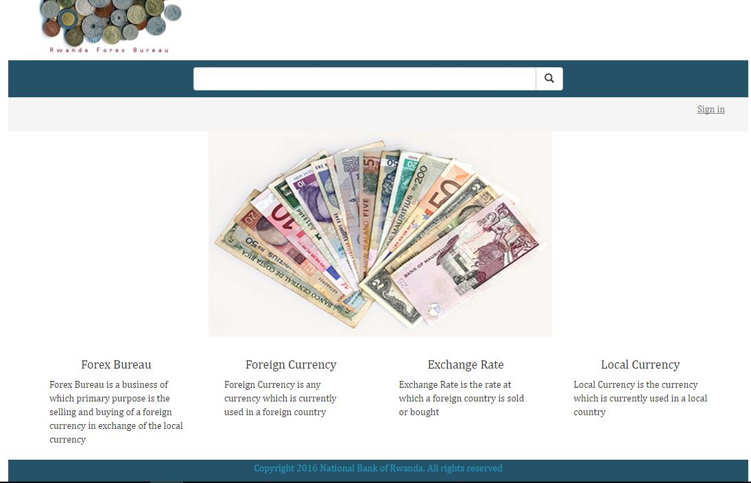

Figure10: Home Page Interface

This is the home page of our web application shows and explain about the local currency, exchange rate and foreign currency and have the option to sign in for the authorized person only.

**The Login form**

This interface in figure below shows first interface of the system login. It allows admin or Forex managers, BNR User and Forex Bureau Teller to access on the system according to their right.

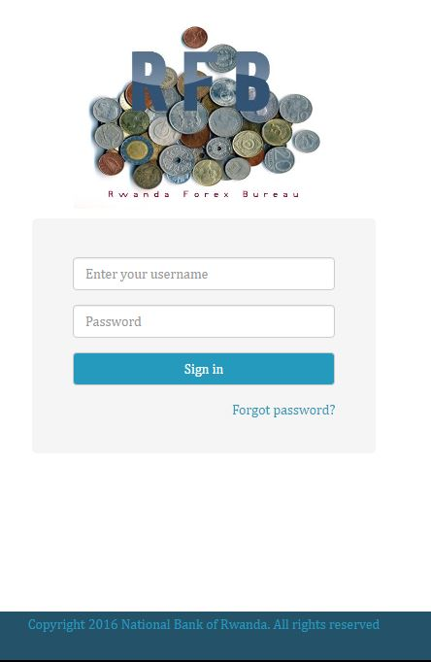

Figure 11: Login Form

**Admin first form**

This interface shows different menus of forex bureau, forex exchange, exchange rate, user, FB location.

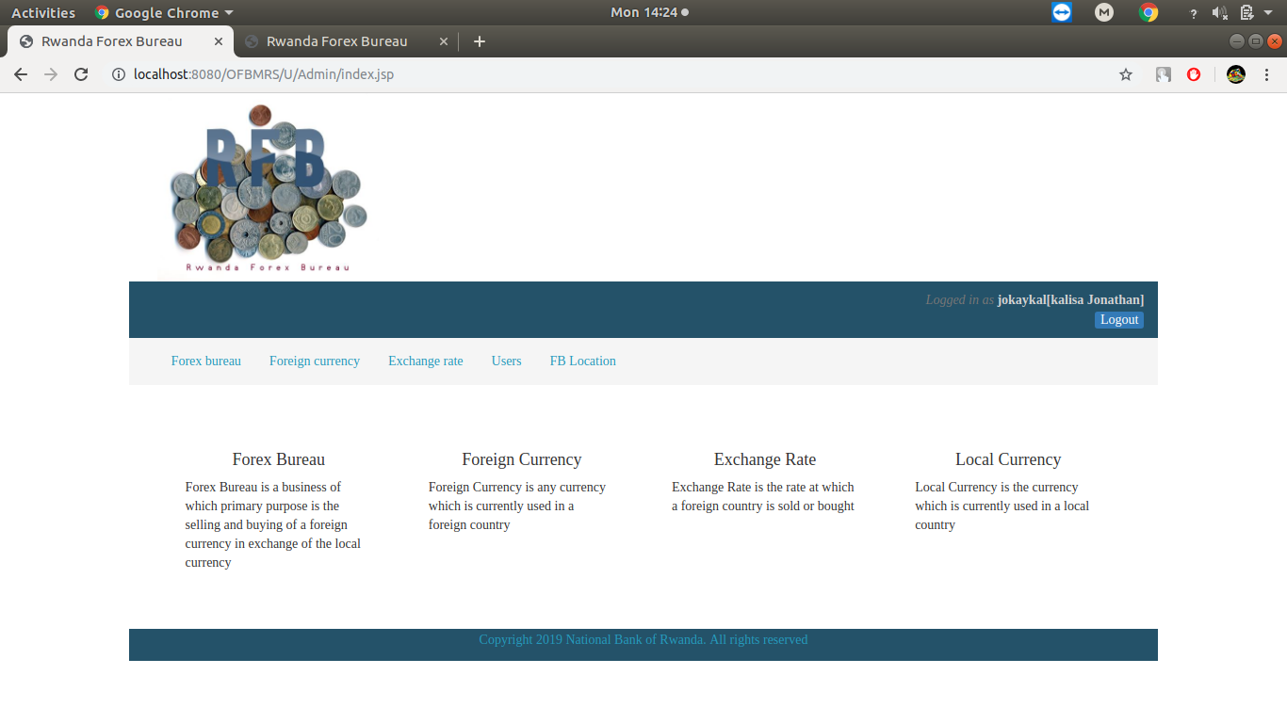

Figure 12: Admin first form

**Add Forex Bureau**

This interface shows how to add forex bureau selecting province, district, sector, cells in which the forex bureau are located.

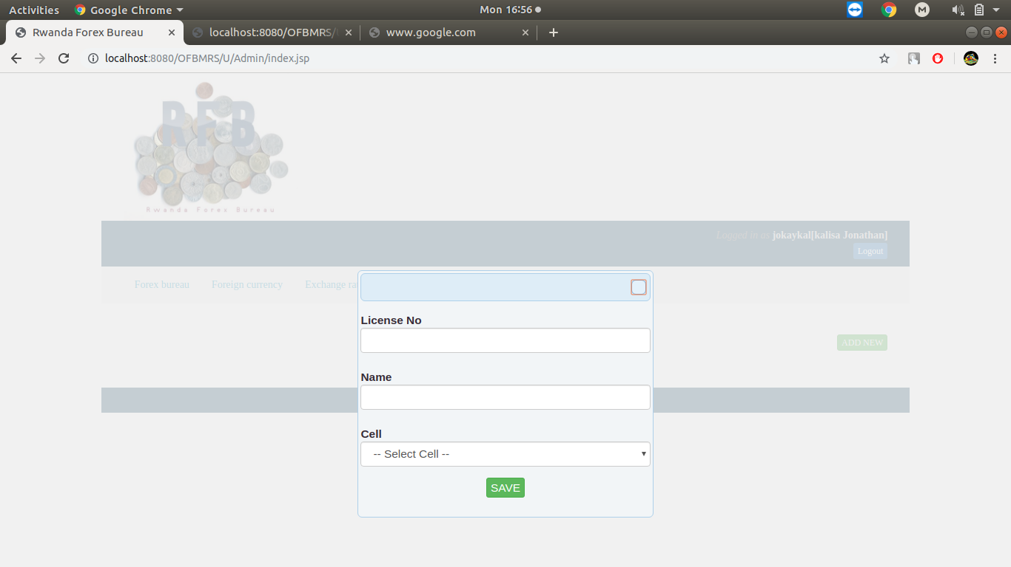**Figure13: Add Forex Bureau**

**Add Managers**

This interface shows how to add users and their information’s like first name, last name, gender, phone, role, username and status.

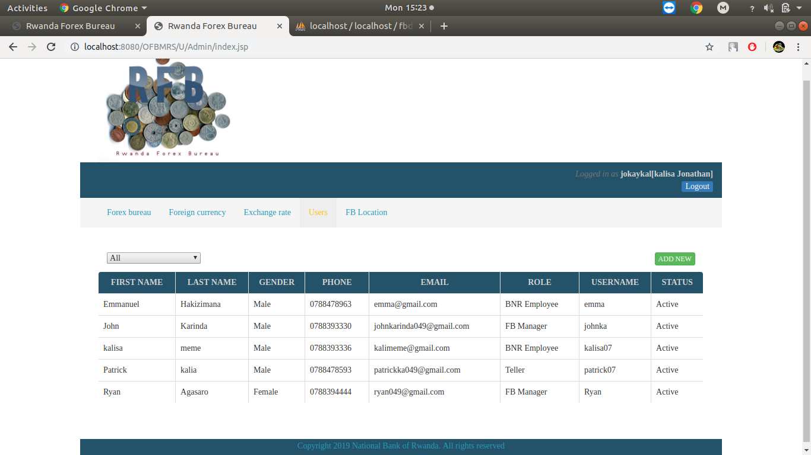

Figure14: Add Managers

**Forex Manager**

This form will show all the thing the forex manager can do which are purchasing, selling, adding tellers, report.

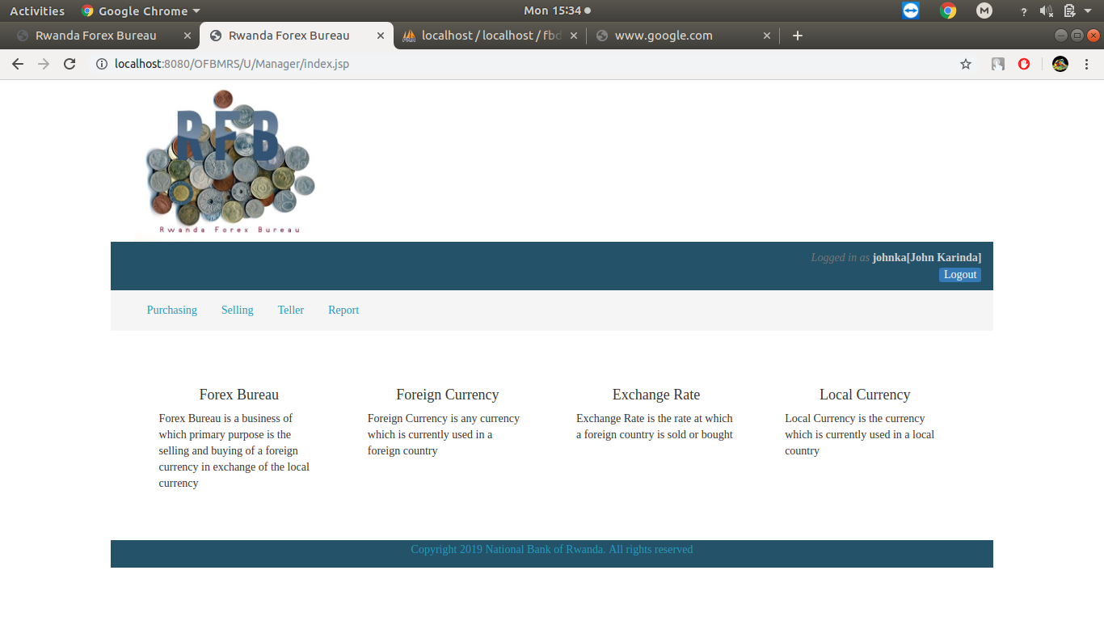**Figure15: forex manager form**

**Foreign currency**

This form will show the current foreign the unit and country.

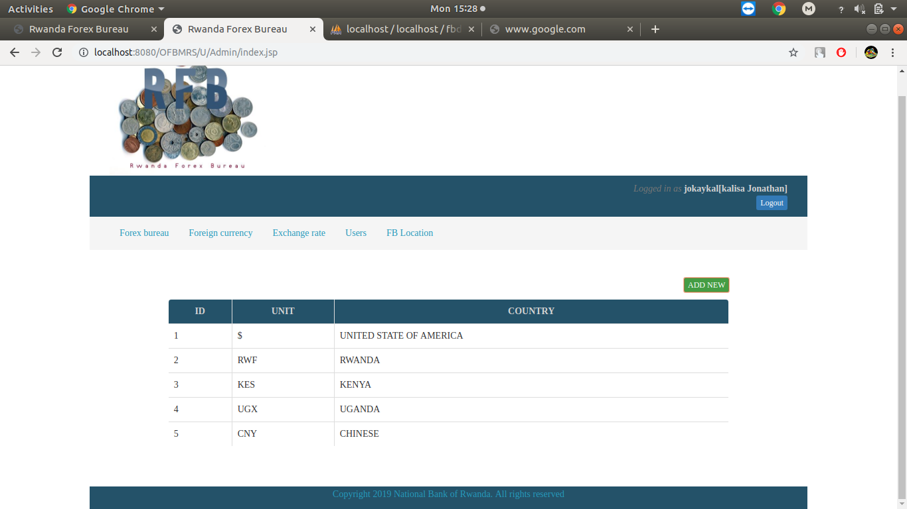

Figure16: foreign currency

## 

**Exchange rate**

This form shows how the rate are according on the actual purchasing, actual selling, minimum purchasing, maximum purchasing, minimum selling, maximum selling, foreign currency, date.

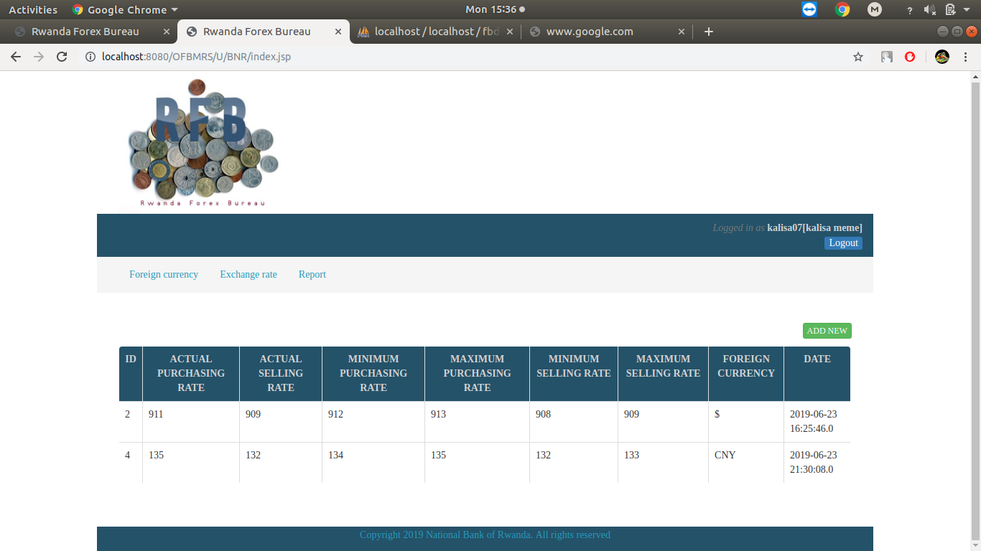

**Figure17: exchange rate**

**Selling and Purchase Report**

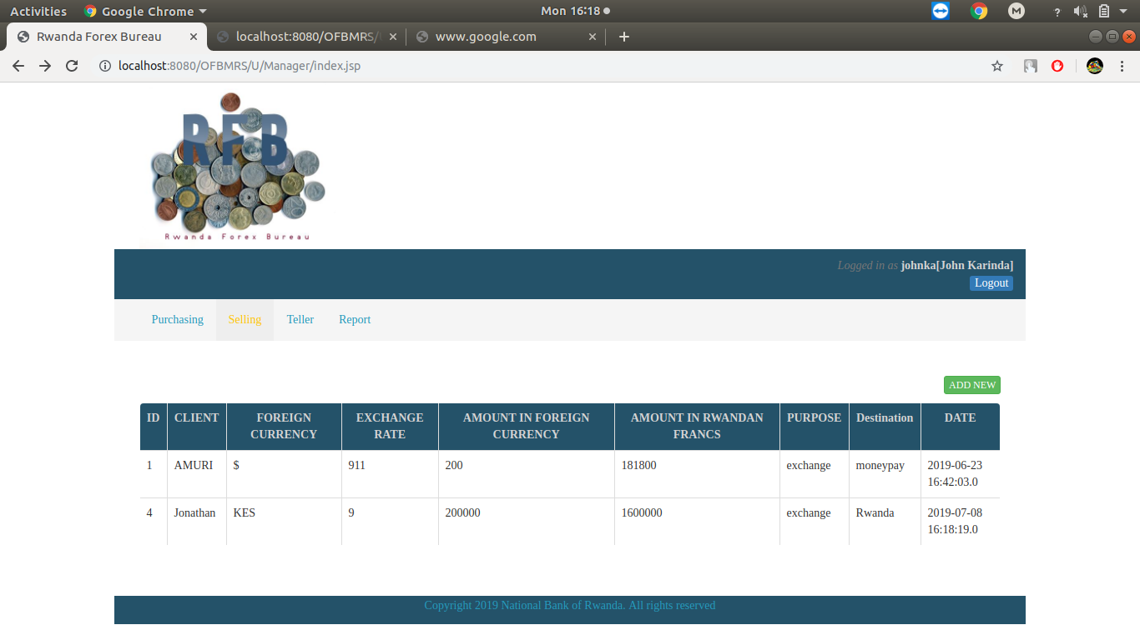

Figure18: Selling Report

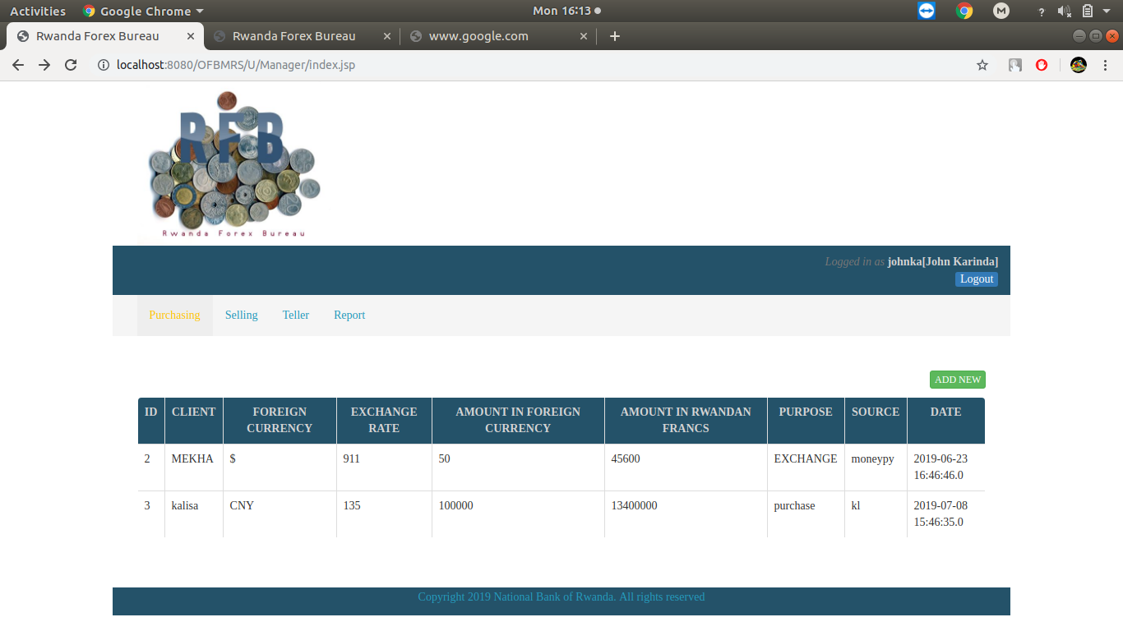**Figure19: Purchasing Report**

## **Software Testing**

Boris Beizeronce said:” Software never was perfect and won’t get perfect. But is that a license to create garbage? The missing ingredient is our reluctance to quantify quality” Software tests play an important role in the software designing. They help to verify the effectiveness of the software to see if it actually does what it was supposed to solve.

Listed are key aspects to take into consideration in software testing

* Does the application meet the requirements that guided its design and development?
* Does the application works as expected?
* Can the application be implemented with the same characteristics and satisfies the needs of the stakeholders?

The following are some software testing

### **Unit Test**

Unit testing is a process to ensure the proper functioning of particular software or a portion of a program. It is a method by which individual units of source code, sets of one or more computer program modules together with associated control data, usage procedures, and operating procedures, are tested to determine if they are fit for use. In other words every small component that can be compiled with the goal to know that every unit matches to its specifications, and to know if there are logical mistakes. Indeed, the unit test is an efficient means that permits to detect the maximum possible mistakes. The application has been checked with the unit test at each piece of the code written.

### **Integration test**

Integration testis the phase in software testing in which individual software modules are combined and tested as a group. This test is useful to check the assembly of the different part of the software. It is also a progression of tests, in which the software and hardware components are collected and tested until the entire system is tested. The application modules have been successively tested until completion to ensure that the whole constituted by the assembled software components answers to the required functional and technical specifications.

### **Validation test**

The last test phase has the role of validating the software in its external environment. The product has been put in final situation in order to verify if it perfectly answers to the needs expressed in the first phase. The validation test is important, since it is necessary to verify if the setting up of the application corresponds to the expressed needs. The application has been tested in its entirety, and it is in this way that we noticed that the progress of operations done corresponds to the functional specifications.

## **Software and Hardware compatibility requirements**

**Client side requirements**:

* A web browser (Mozilla Firefox, Google Chrome, Torch, etc.)
* Operating system (Windows xp, vista, 7, 8 10; Linux, iOS).
* A RAM of 512 Megabyte (minimum)
* A hard disk of 8 Gigabyte of free space

**Server side requirements:**

* Java SE Development Kit;
* A Web server which support Java and JSP (TOMCAT, GLASSFISH, etc.);
* MYSQL SERVER 5.5;
* Network cark: 1GB/Second;
* RAM: 1GB minimum;
* 2GB or Freer hard disk space.